Blakesley Hall
School Group Goodie Bag Order Form

We stock a range of items suitable to be purchased in the form of goodie bags for groups who may not have time to visit the shop on their visit (which you are more than welcome to do!)

We have the following bags available;

- £1.25 bag (Blakesley Pencil and Garden Postcard in a bag)
- £2.15 bag (Blakesley Pencil, Garden Postcard and Sharpener in a bag)
- £2.75 bag (Blakesley Pencil, Garden Postcard and Magnet in a bag)
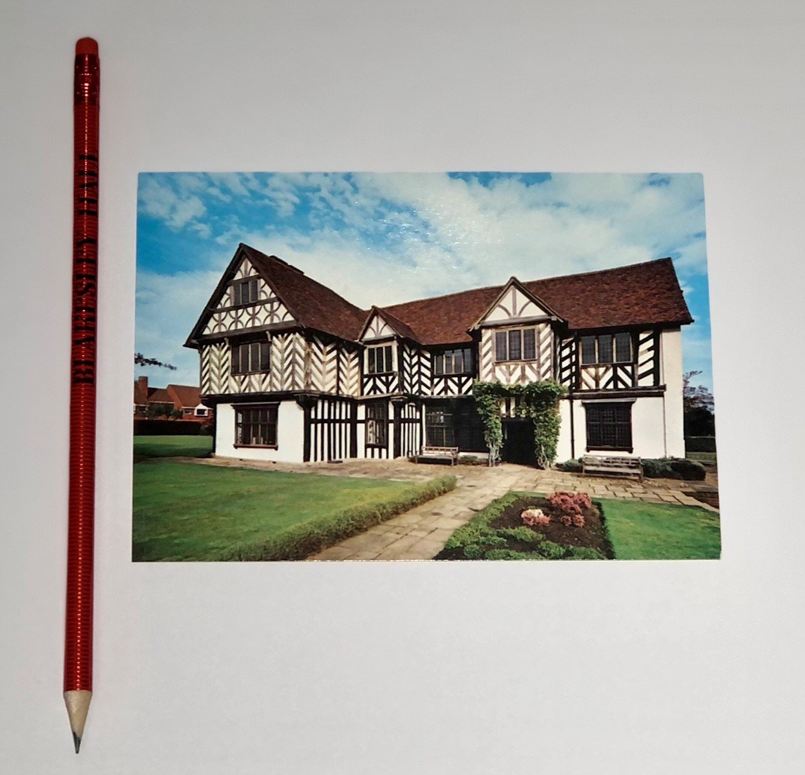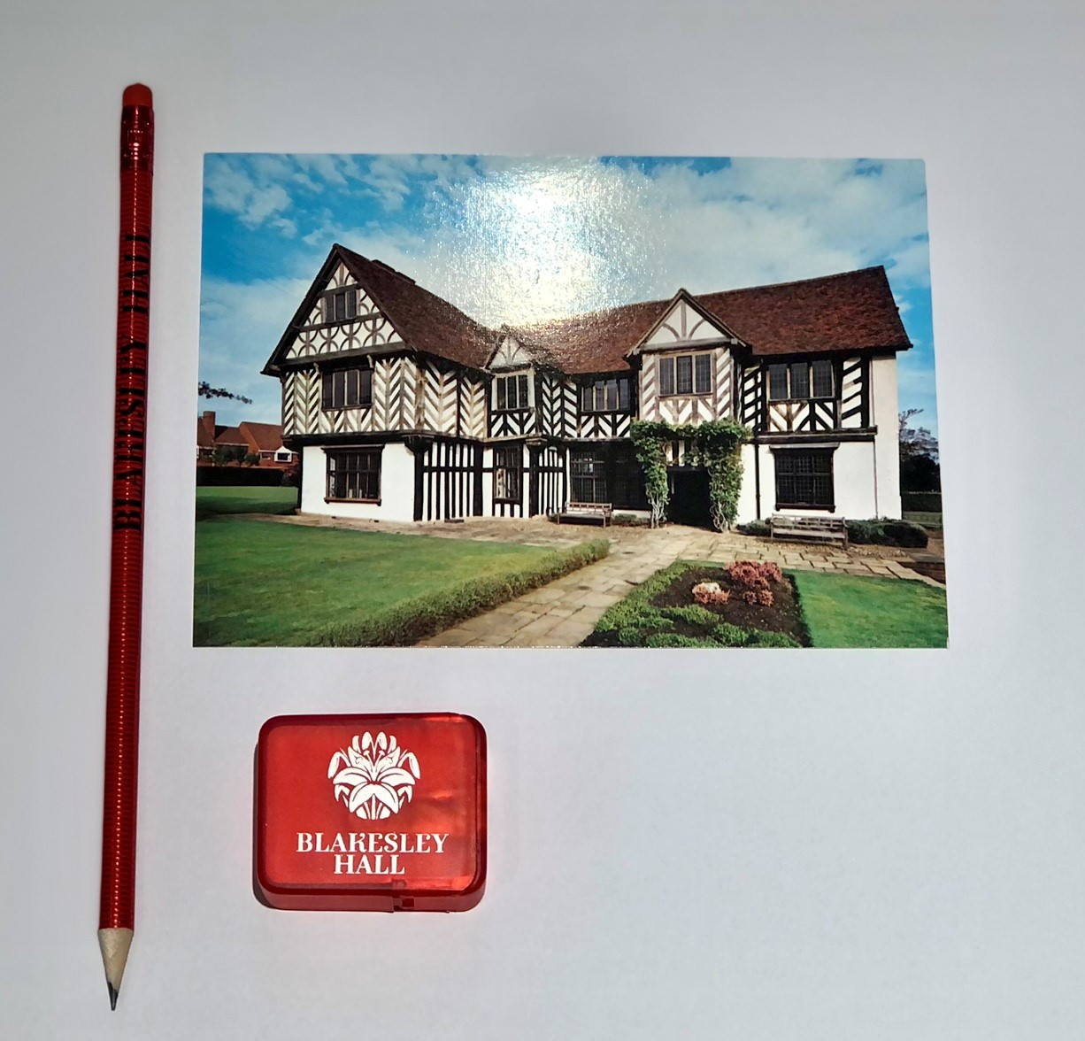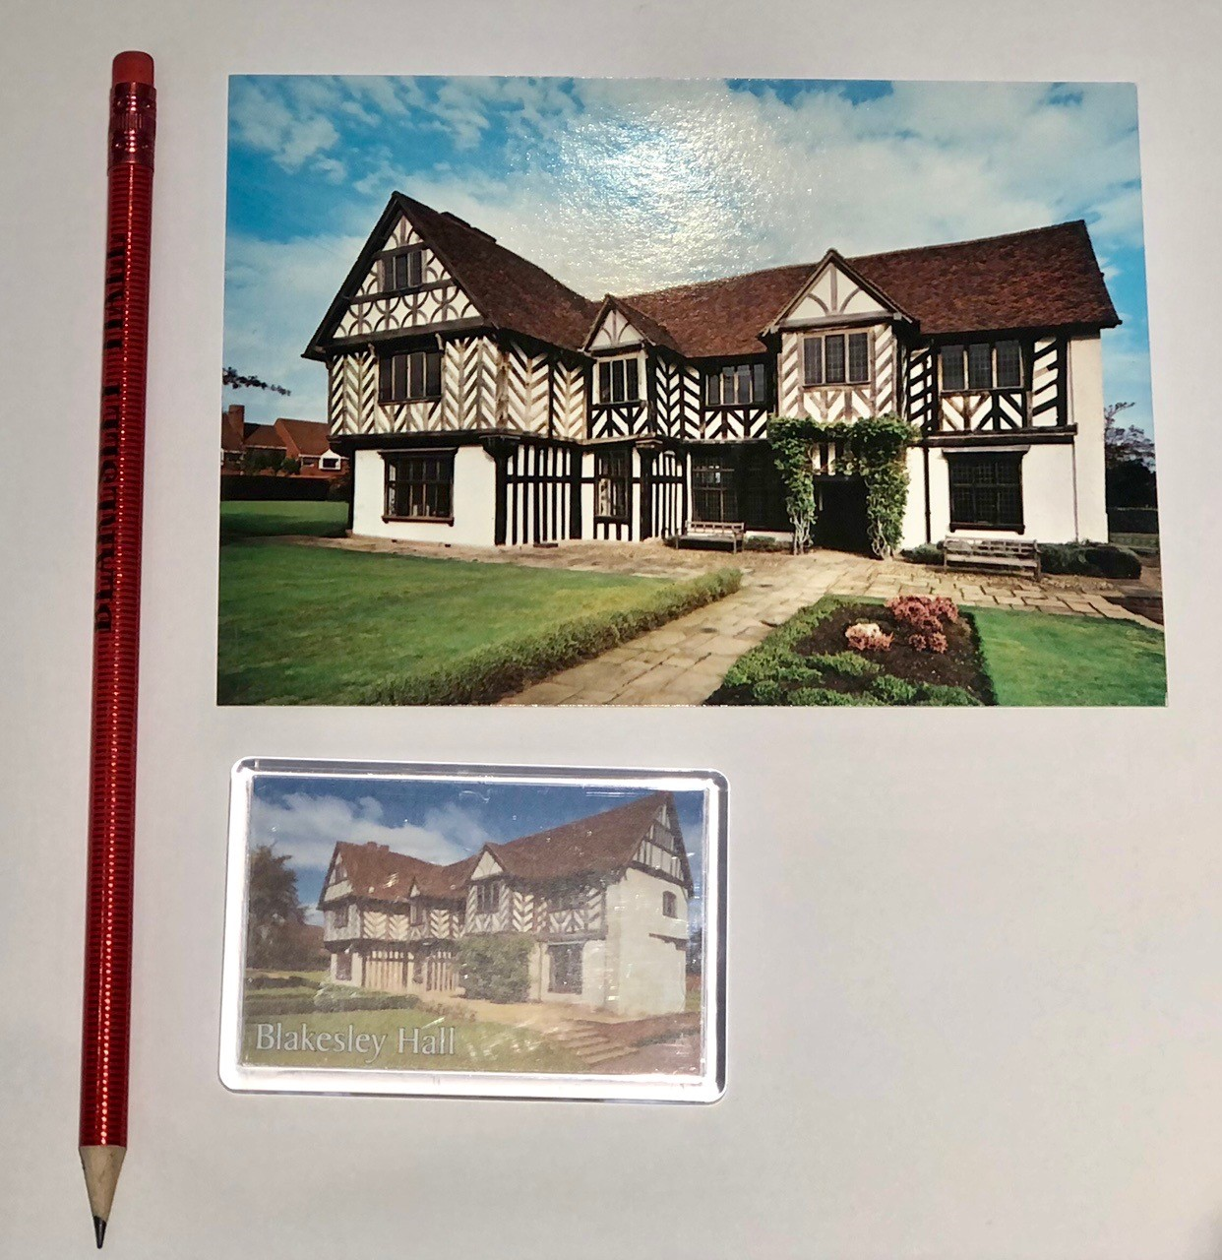

Goodie Bag | Quantity Ordered | Price per bag | Total Price
Blakesley Pencil and Garden Postcard in a bag |  | £1.25 each
Blakesley Pencil, Garden Postcard and Sharpener in a bag |  | £2.15 each
Blakesley Pencil, Garden Postcard and Magnet in a bag |  | £2.75 each

Please complete the order form and return to: educationbookings@birminghammuseums.org.uk

Name of School:
Contact number/ Email:
Date of Visit:
Payment method (please circle): cash, card or invoice.

